Review:
- Behavior is observable and measurable
- Every behavior has a function/purpose/is not random
- Challenging behavior is usually communicative
- Challenging behavior is often related to events before and after
- Therefore, identify a reason for the
problem behavior

Communication as a Function:
- Every behavior has a purpose
- Regardless of whether challenging behavior is for Sensory, Escape, Attention, Tangible, it is also typically because the individual has a tough time communicating
- Analyze the function – What is the person trying to say?
- Teach Functional Communication Training (FCT) as part of any good ABA program

Classifying the Main Functions of Behavior – Why Does Behavior Occur?

S | Sensory | The behavior feels good or meets a sensory need
E | Escape | From person, task, environment
A | Attention | Desire for attention from peers, adults
T | Tangible | Desire for a specific item, activity, “My way”

NOTE: A behavior can serve multiple functions

Determining Function:

Antecedent | Behavior | Consequence
What happened before  the behavior | Behavior of concern | What happened after  the behavior

Developing a Treatment Plan:
- Treatment must be feasible in natural situations
- Plan must be customized to the individual
- Consider the ability of the caregivers/teachers to implement the plan consistently
- Program for generalization & maintenance of treatment effects

Rules to Incorporate into Treatment:
- Always teach replacement behavior
- Functional communication training: Recognize antecedent and prompt appropriate language/communication
- Use of antecedent strategies can prevent problem behavior altogether
- Change consequences (do opposite of function)
- Reinforcement systems

What’s in it For Me?
- Why should I behave properly when screaming/kicking/yelling [insert other negative behavior here] gets me what I want??? (and fast!)
- Why do you require me to do so much to get what I want when I can [insert negative behavior here] and get it immediately?

ESCAPE/AVOIDANCE

Replacement Behavior:
- Functional Communication Training (FCT)
  - I need a break
  - I need help
  - This is too hard
  - Etc.
- Tolerating non-preferred activities
- Tolerating error correction/assistance
- Shaping time on task
- Tolerating transitions/delays/waiting

Antecedent Strategies:
- Program for frequent breaks contingent upon appropriate behavior
- Follow less preferred activities with highly preferred activities (first/then)
- Offer 2-3 choices for non-preferred activities (forced choice)
- Provide clear visual/verbal cues for beginning and end of a task (e.g., timer, verbal countdowns, “Just this page”, “2 more”, “These 5 and that’s it”, etc.)
- Clear expectations – clear and concise instructions
- Use visuals while providing instruction
- Behavioural rehearsal (e.g., role play, video model, social storyTM, etc.)
- Group chants (e.g., “When I wait quietly, I get what I want”) (Hanley et al., 2007)
- Time timers
- First/Then boards
- Visual Schedules
- Choice Boards
- Social Stories / Social Narratives
- Video Modeling

Curricular Revisions:
- Reduce the effort of the task demand
- Ensure that the level of the task demands are equivalent with the student’s skill level
- Reduce the # of responses/items/duration of the task
- Increase the size of the items per page
- Color vs. black and white curriculum materials
- Form of task (e.g., pencil/paper vs. audio/oral instructions/responses)
- Reduce boredom of task (be creative and make task exciting)

To Increase the Likelihood of Compliance:
- Identify a positive contingency for compliance (i.e., what’s in it for them to comply)
- Use specific rather than general requests (i.e., don’t give the option by saying, “Can you do…?” Instead, just say, “Do this”)
- Do not repeat requests – say it once, then follow through by providing guidance if necessary

Consequence Strategies:
- Follow through with task demand
- Goal = Do not let the problem behavior make the demand go away
- Block access to reinforcement until compliance occurs
- Praise for attempts

ATTENTION

Replacement Behavior:
- Functional Communication Training:
  - Look at this / See…
  - Come here
  - Let’s play
  - Want to hear a joke?
  - Raise hand
- Appropriate waiting
- Independent leisure skills

Antecedent Strategies:
- Provide regularly scheduled attention
- Provide interesting activities for individuals to engage in when adult attention is diverted (e.g., books, blocks, etc.)
- Provide predictable signals of when attention will be available (i.e., 10 minutes, when this worksheet is done)
- Reinforce for on-task behavior
- Reinforce for appropriate attention-seeking behavior
- Reinforce for playing quietly

Consequence Strategies:
- Ignore the behavior (not the individual)
- Stay neutral (avoid facial reactions)
- If it’s safe, walk away and engage yourself in another activity
- If it’s safe, briefly remove the child from the activity

TANGIBLE

Replacement Behavior:
- Functional Communication Training
  - I want…
- Tolerating waiting
- Tolerating sharing
- Terminating preferred activities
- Transitioning to a less preferred activity
- Accepting “no”

Antecedent Strategies:
- Provide scheduled toy and activity changes
- Offer food/drink/toilet regularly and predictably
- Identify precursor behavior (i.e., grimacing, restless behavior) that may indicate a need and prompt for appropriate alternative behavior
- Offer alternatives when denying requests
- Sharing: “Trade you”
- Teach waiting: “When I wait quietly, I get what I want”
- Provide a clear warning for transitions (e.g., flashlights off and on, 1-min warning, countdown from 10)
- Rearrange sequence of events so that non-preferred activities are followed by preferred activities
- First/Then
- Visual schedule that indicates when student can access tangible

Consequence Strategies:
- Do not give the student the toy/activity
- Redirect to another item/activity
- Wait until the student is calm for 5 seconds and then prompt them to ask appropriately

SENSORY

Replacement Behavior:
- Determine the function of the sensory behavior
- Offer function-based, appropriate alternatives (e.g., chew toy instead of biting finger)
- Time and place

Antecedent Strategies:
- Engagement
  - Limit down time so individual cannot practice stereotypic behavior
  - Provide appropriate leisure activities that may provide same feedback
  - Enrich environment
- Structure
  - Structure individual’s day with reliable and predictable sequence of leisure activities

Consequence Strategies:
- Block/Interrupt the behavior
- Redirect the individual to a more appropriate activity (i.e., replacement behavior)
- Reinforce/Praise for engaging in more socially appropriate behavior

IN CONCLUSION

Warning:
- Extinction Burst: Behavior may get worse before it gets better
- If behavior is accidentally reinforced, it can get worse and stay worse – behavior can occur at a higher rate than when you started
- Therefore, if true extinction cannot be done, then don’t use extinction as part of your treatment plan

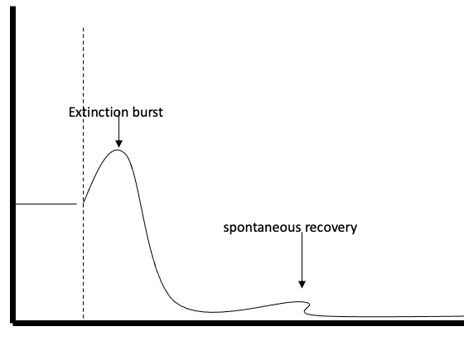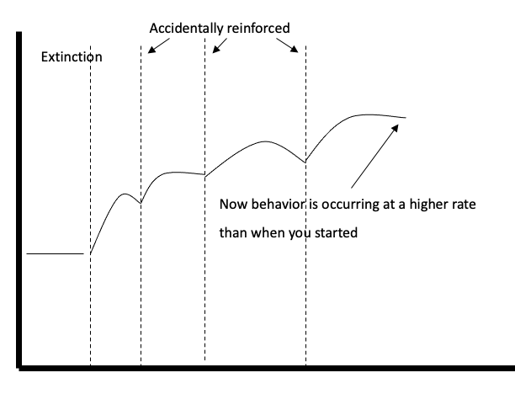

Summary:
- Teach permanent replacement strategies
  - Eliminating the behavior without teaching individuals functional ways to replace the behavior is only a temporary solution
- Problem behavior serves many purposes depending on the environment, situation, etc.
  - Therefore, multi-component interventions may be needed
- Intervention involves changing social situations and environments – Not the individual
  - Intervention is not something that you do to an individual, it is something that you do with an individual

Lifestyle Change is the Ultimate Goal:
- Successful interventions allow a person to influence others without having to resort to problem behavior
- They permit an individual to participate directly in the community and have more social, vocational and leisure opportunities

References:
- Cooper, J. O., Heron, T. E., & Heward, W. L. (2019). Applied Behavior Analysis (3rd Edition). Hoboken, NJ: Pearson Education.
- Carr, E. G., Levin, L., McConnachie, G., Carlson, J. I., Kemp, D. C., & Smith, C. E. (1994). Communication-based intervention for problem behavior: A user's guide for producing positive change. Paul H Brookes Publishing.

