Review:

Communication as a Function:

Classifying the Main Functions of Behavior – Why Does Behavior Occur?

S
E
A
T

NOTE: A behavior can serve multiple functions

Determining Function:

Developing a Treatment Plan:

Rules to Incorporate into Treatment:

What’s in it For Me?

ESCAPE/AVOIDANCE

Replacement Behavior:

Antecedent Strategies:

Curricular Revisions:

To Increase the Likelihood of Compliance:

Consequence Strategies:

ATTENTION

Replacement Behavior:

Antecedent Strategies:

Consequence Strategies:

TANGIBLE

Replacement Behavior:

Antecedent Strategies:

Consequence Strategies:

SENSORY

Replacement Behavior:

Antecedent Strategies:

Engagement | Structure

Consequence Strategies:

IN CONCLUSION

Warning:

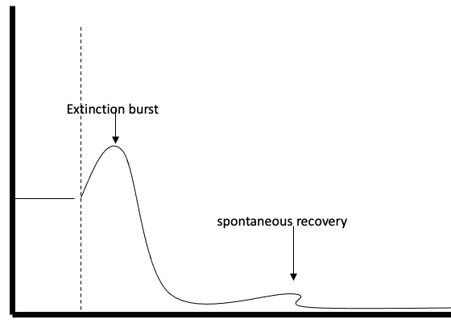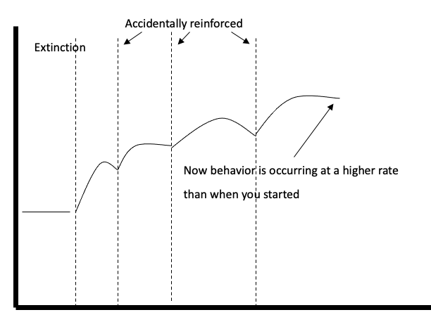

Summary:

Lifestyle Change is the Ultimate Goal:

References:
- Cooper, J. O., Heron, T. E., & Heward, W. L. (2019). Applied Behavior Analysis (3rd Edition). Hoboken, NJ: Pearson Education.
- Carr, E. G., Levin, L., McConnachie, G., Carlson, J. I., Kemp, D. C., & Smith, C. E. (1994). Communication-based intervention for problem behavior: A user's guide for producing positive change. Paul H Brookes Publishing.

